STEP 1, 2

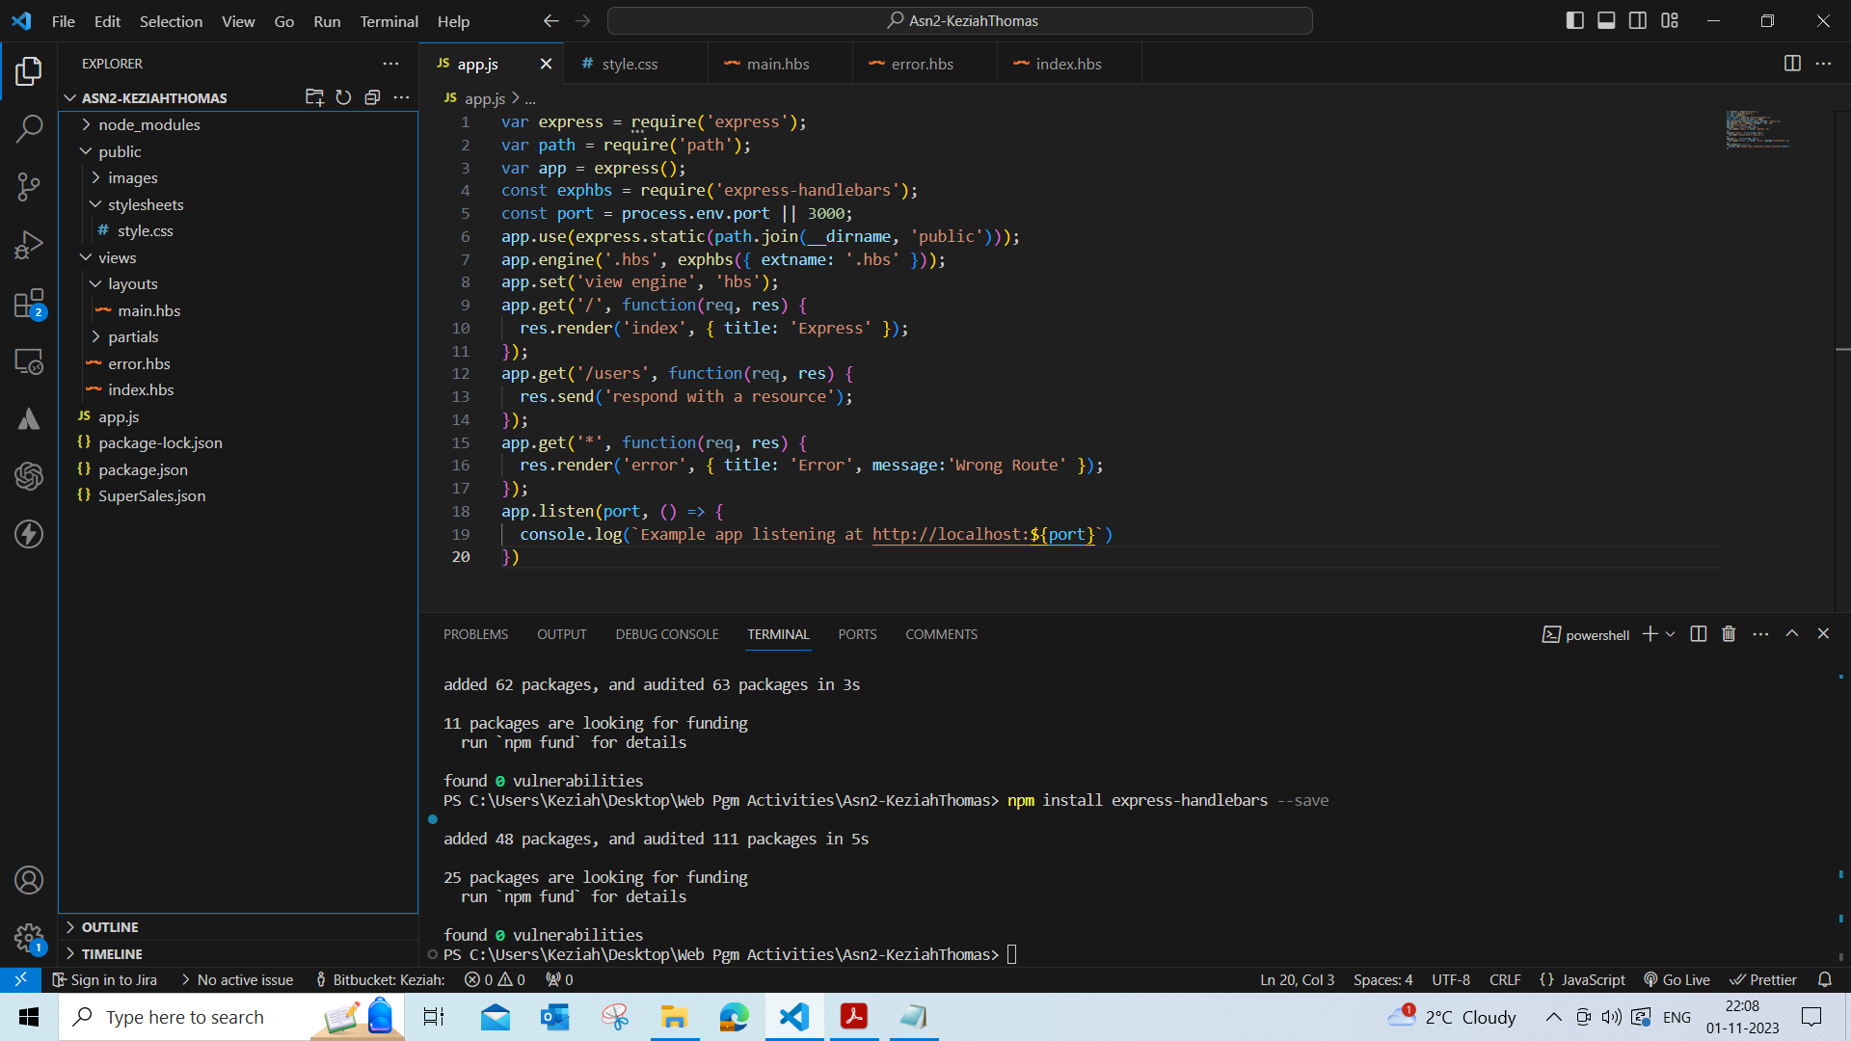

STEP 3

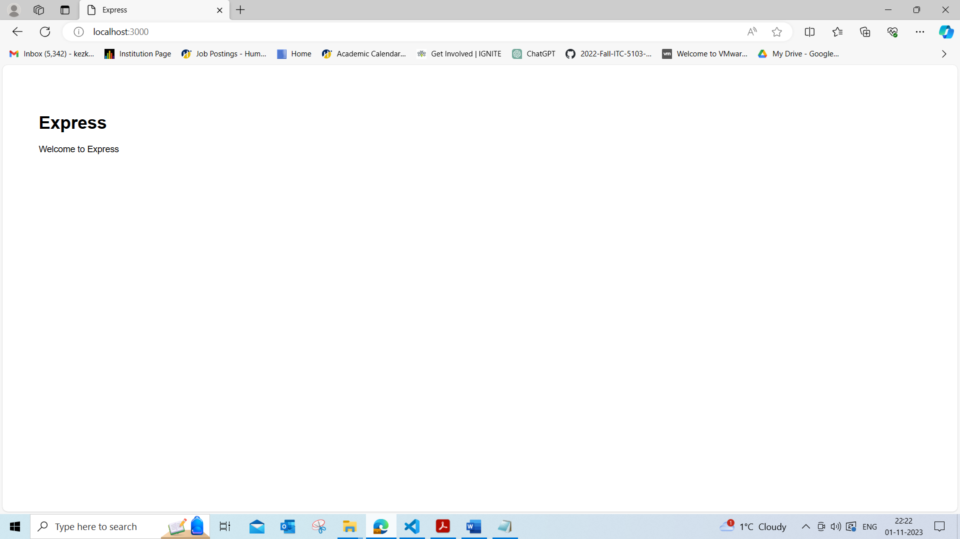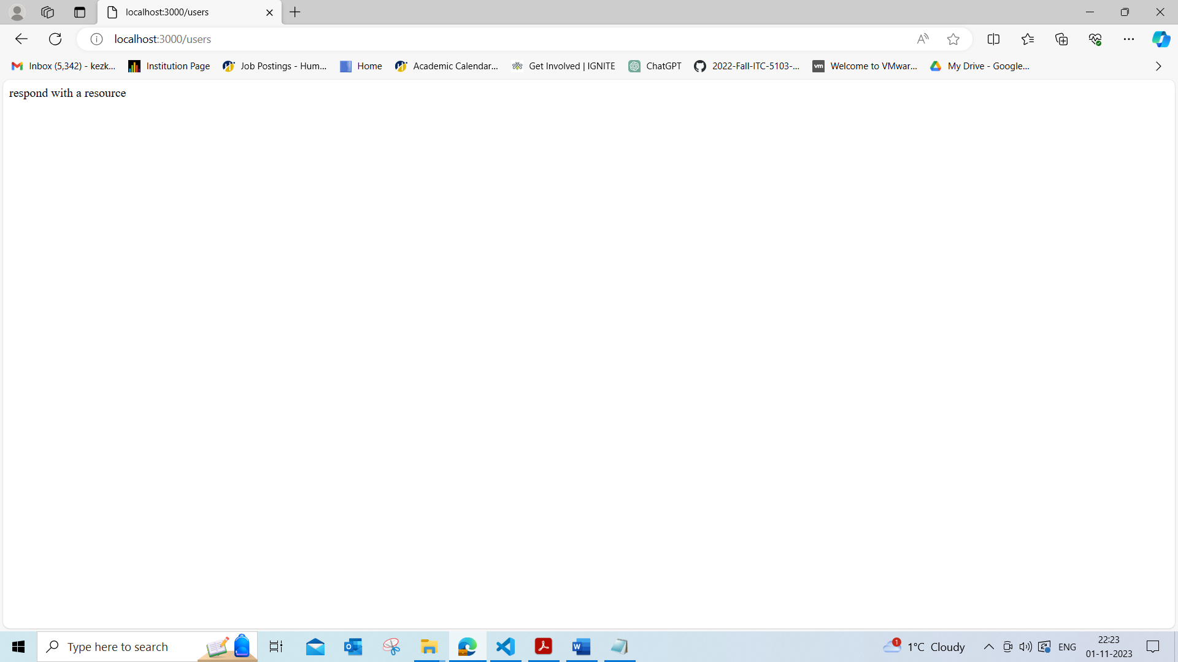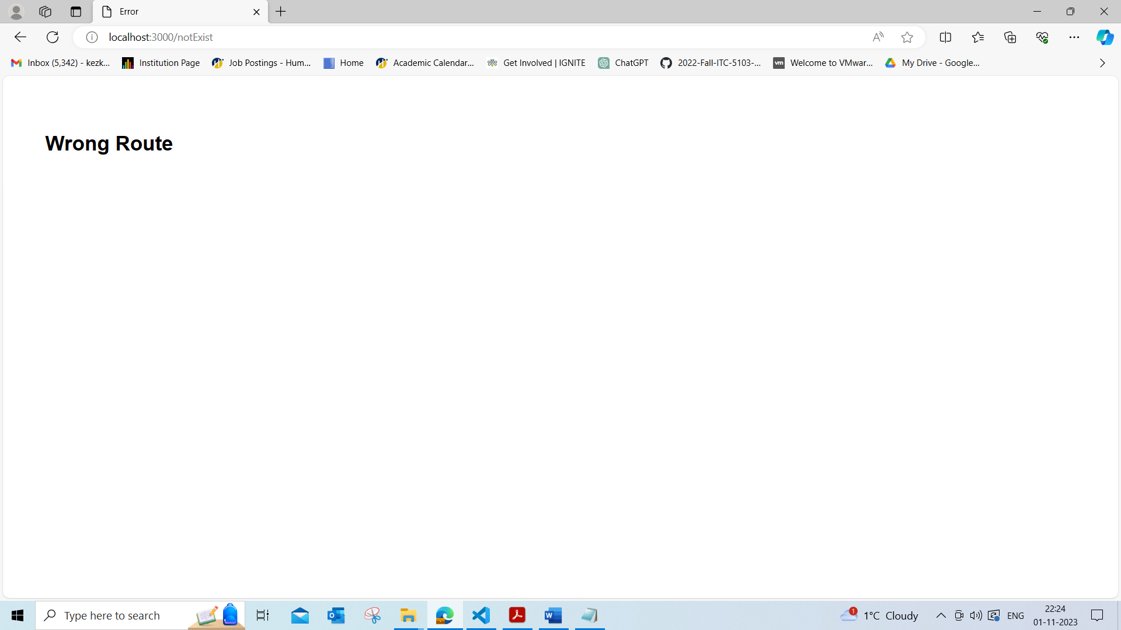

STEP 4

1. Main.hbs is the main layout file of the application. It includes the common structure of the HTML page, such as the head, header, and footer. This file is used as a template where other views are embedded into the HTML page.
2. "index.hbs" is the template that’s rendered when users navigate to ‘/’. It defines the structure and content of this specific page. "error.hbs" is the template used for displaying error messages, providing a consistent and user-friendly way to handle errors throughout the application. This file is rendered in case of non-matching routes.
3. It sets up a static file server to serve static assets from the "public" directory. This is essential for serving CSS, JavaScript, images, and other static files to the client. If we comment it out, the server won't be able to serve these static files.
4. 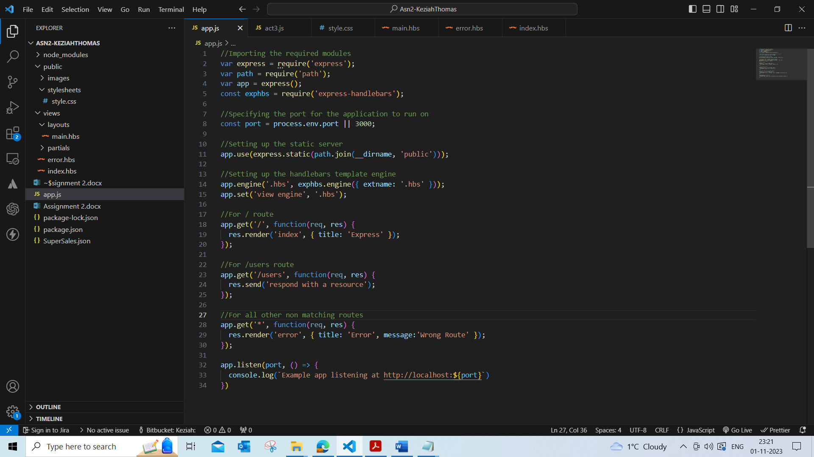

STEP 5

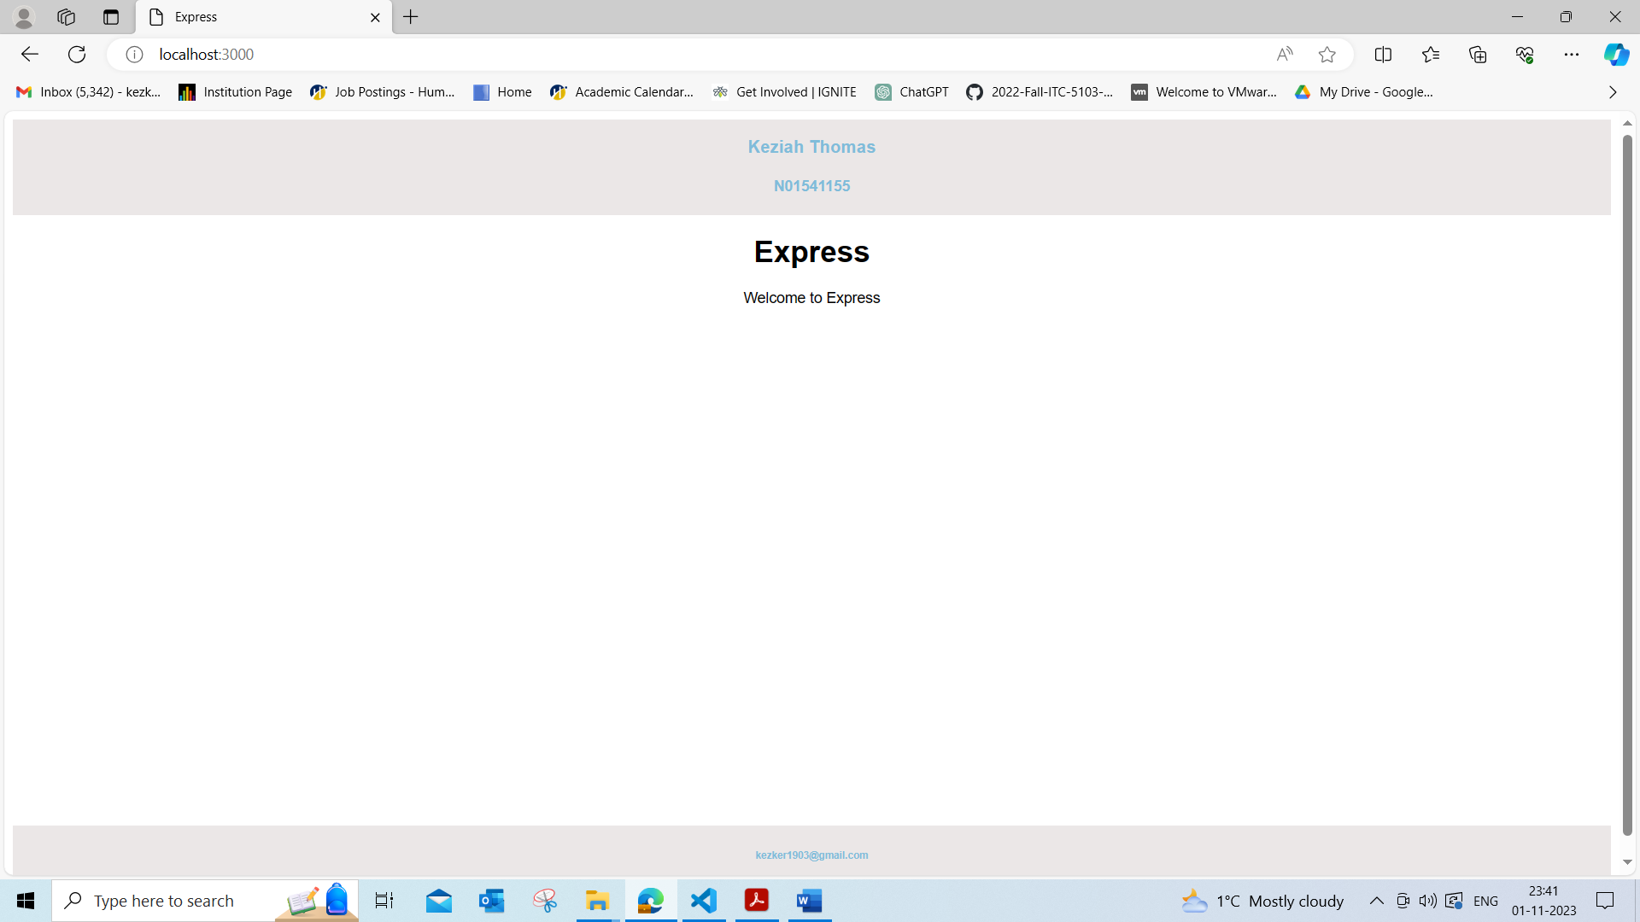

STEP 6

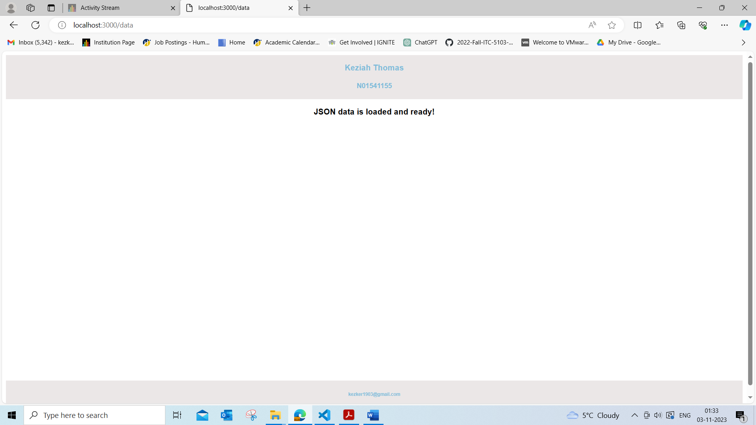 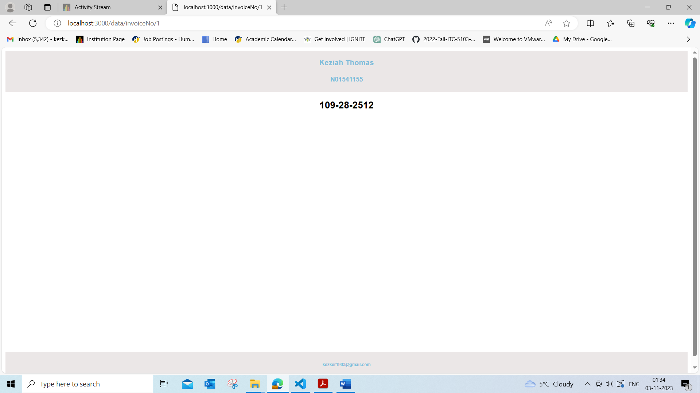 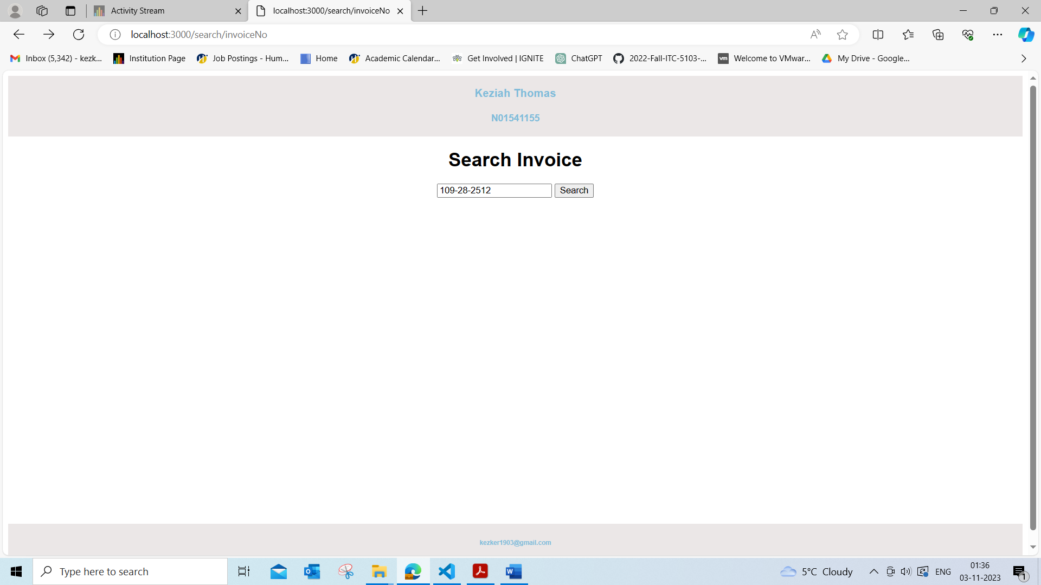 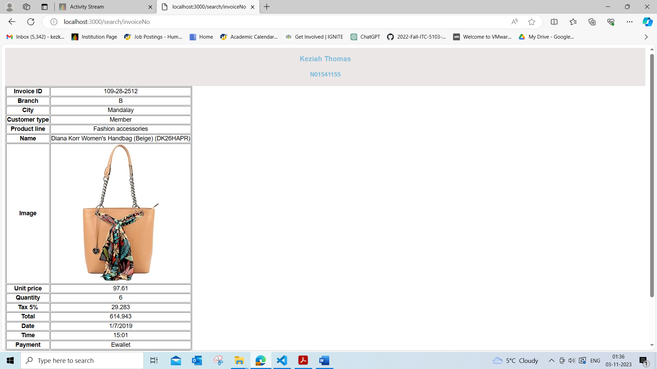 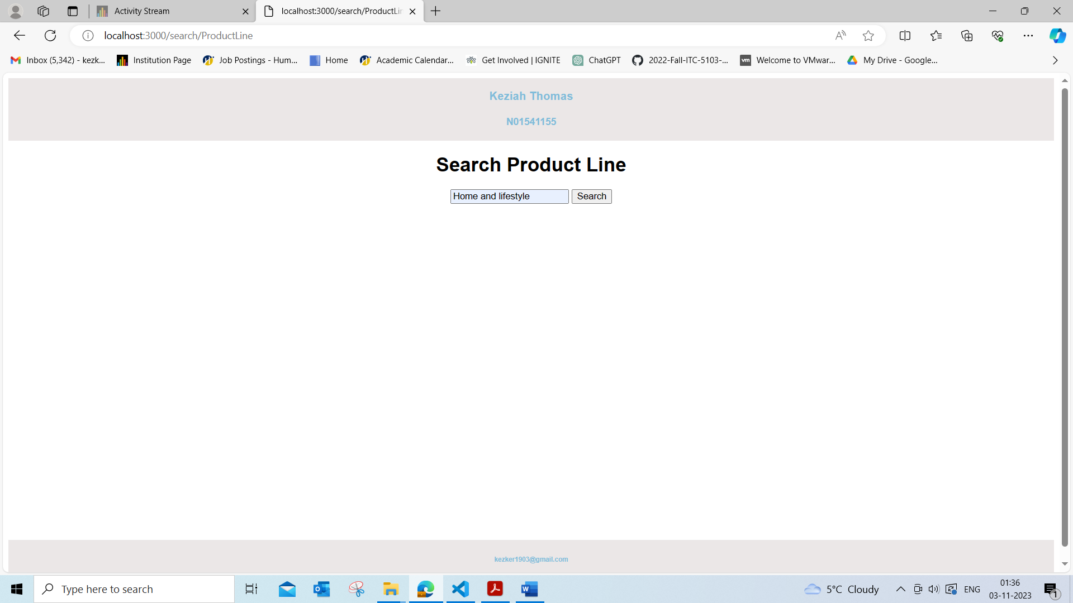 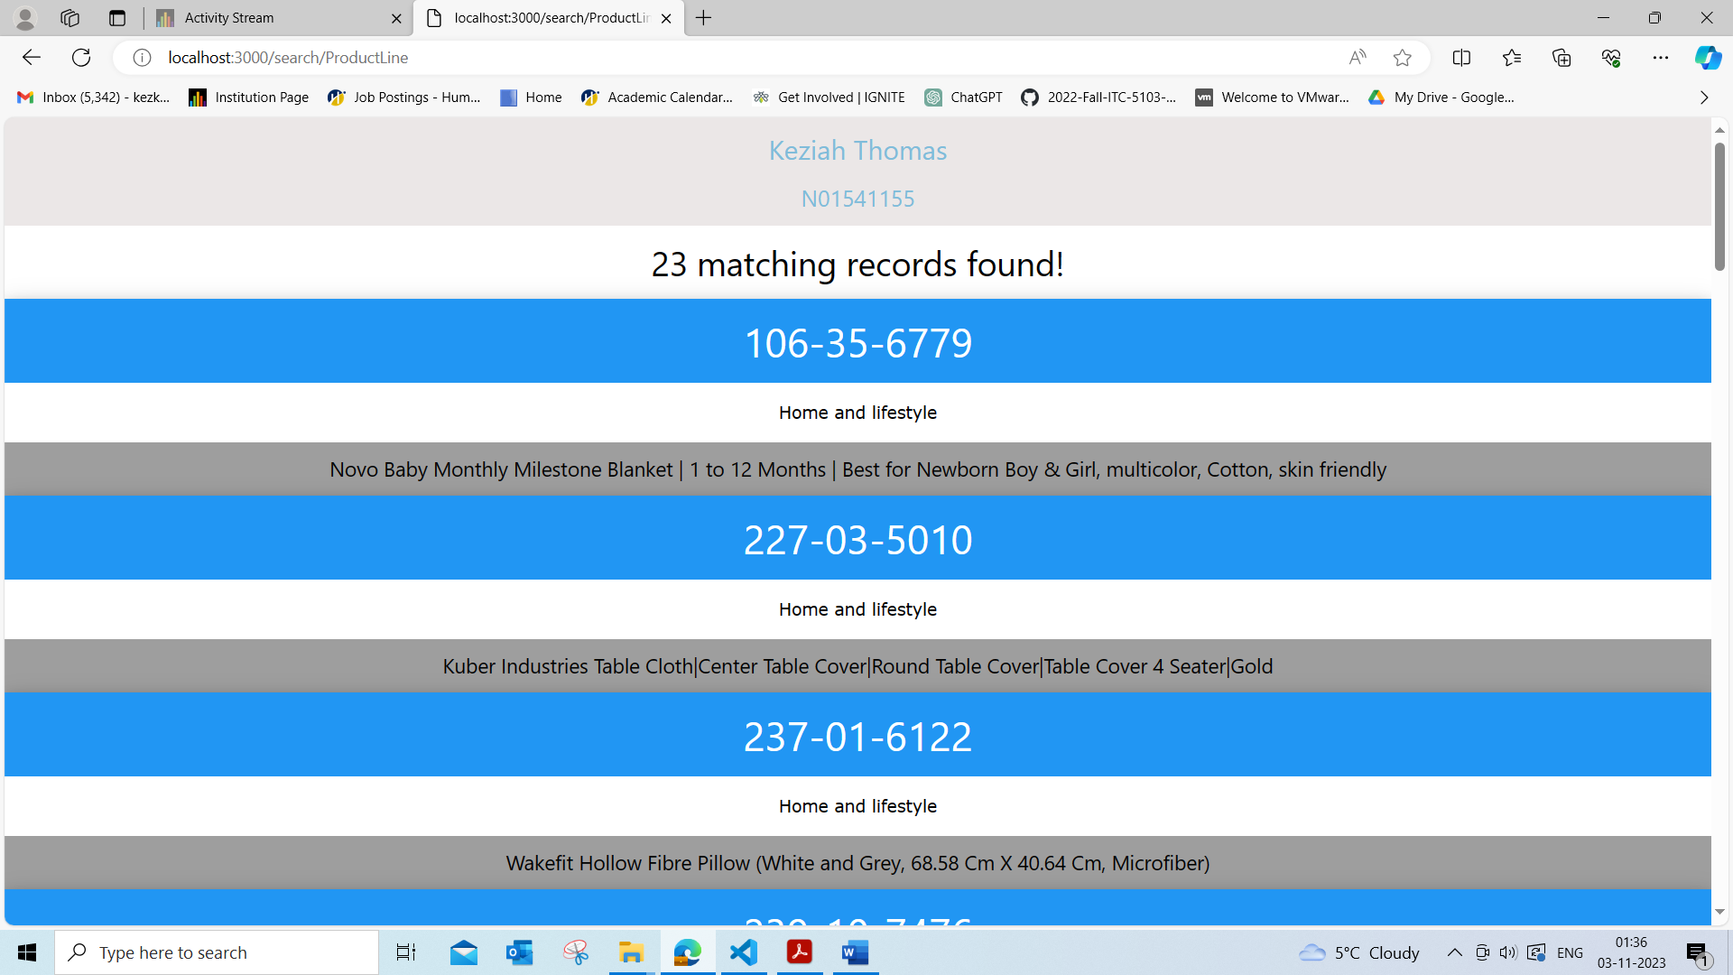

STEP 7

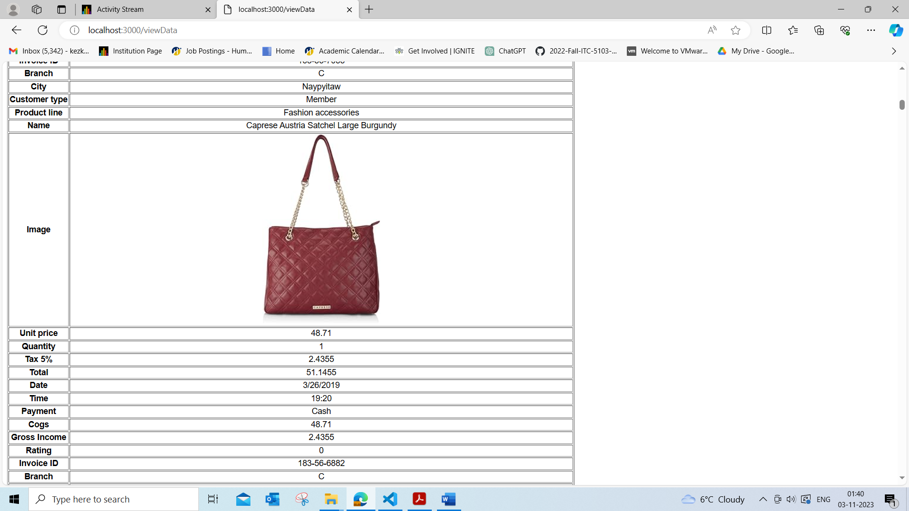

STEP 8

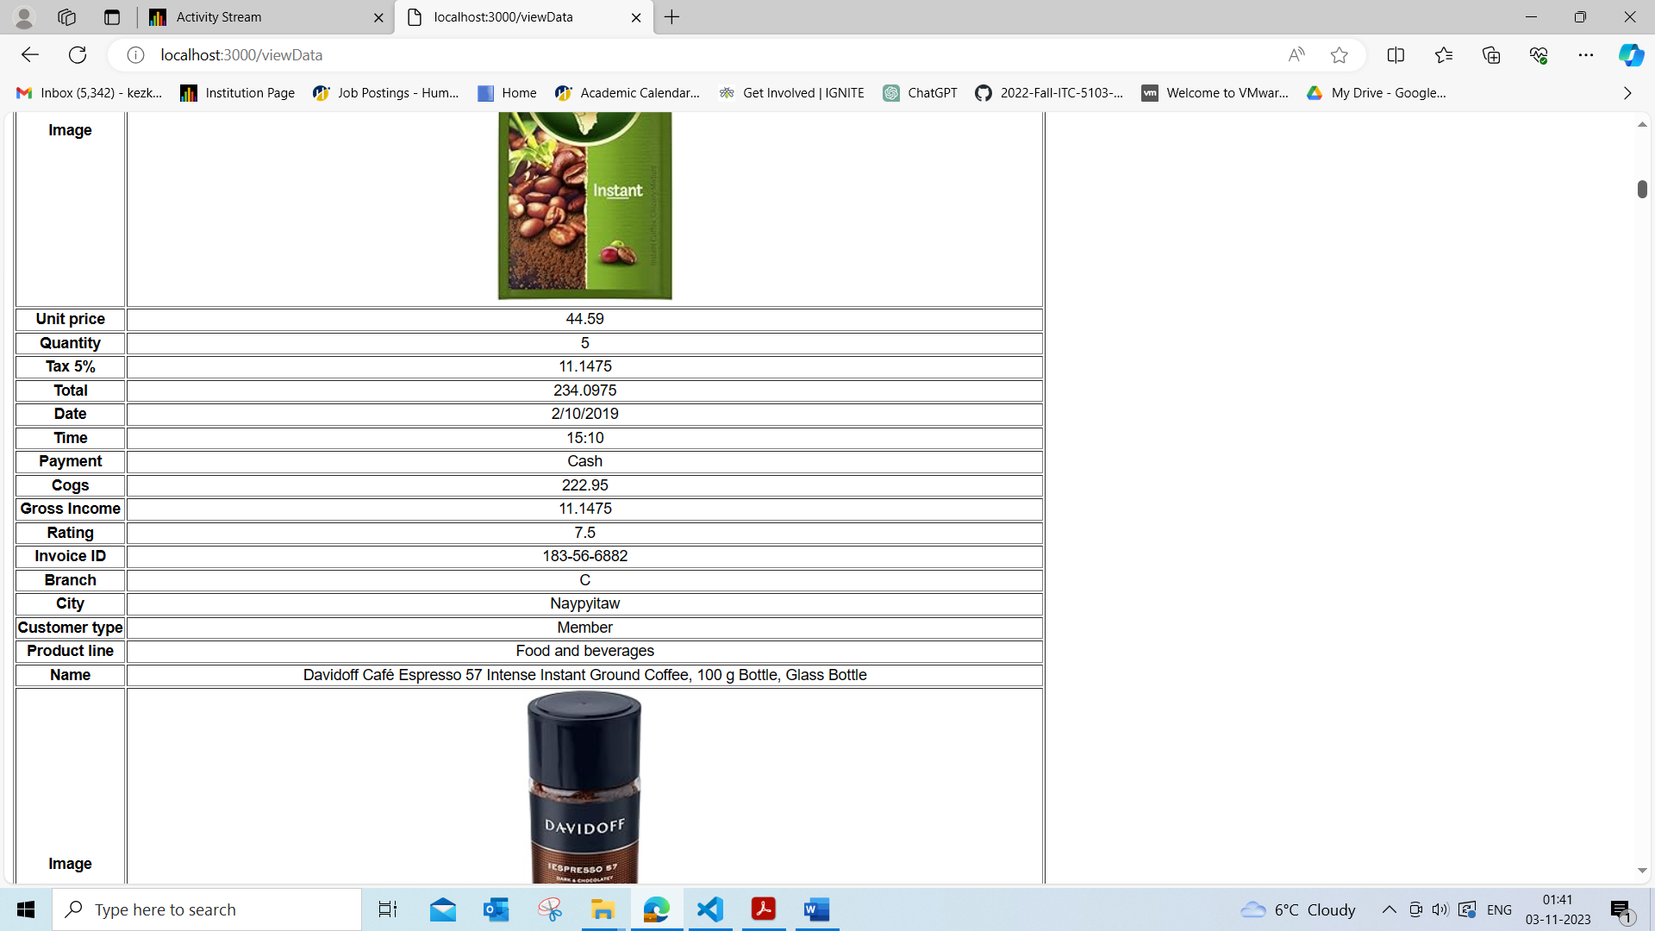

STEP 9

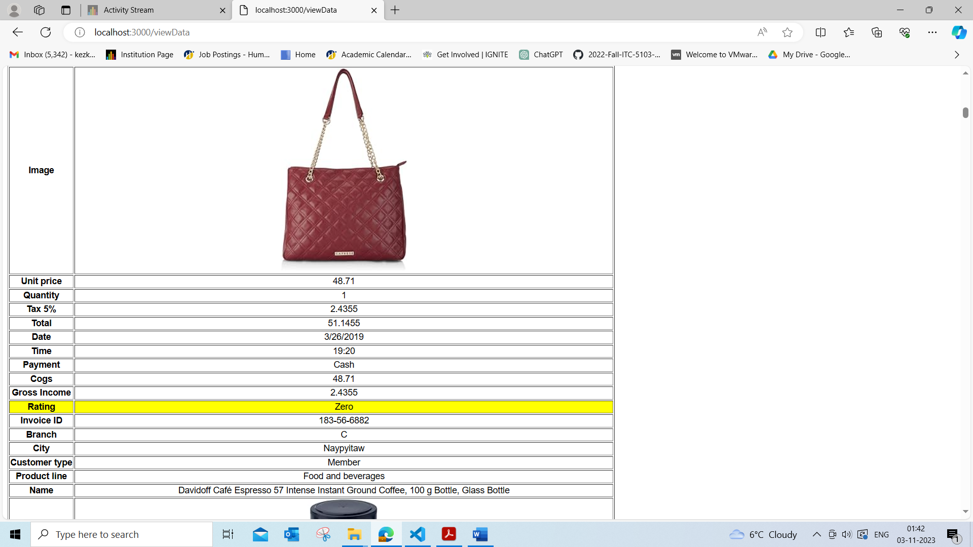

STEP 10

1. You want to change table row color for those records which “rating” is “0”. Any way that you can implement it using Template Engine?

Implemented in STEP 9

1. In this app, do you find any use cause for utilizing “Partial” Templates? Explain your answer

Yes, “Partial” Templates allow you to break down a larger template into smaller, more manageable pieces. This increases modularity and ease of maintenance. If you need to make changes or updates to a specific part of the page, you can focus on the relevant partial template without touching the rest of the code. It promotes code reusability.

Implemented from STEP 5 onwards

STEP 11

